CHAPTER 1

INTRODUCTION

The project focuses on developing a Vehicle Accident Alert System intended to reduce fatalities caused by delays in emergency response. Road accidents are one of the major causes of death and injury worldwide. Delay in providing medical assistance is often the reason behind the high fatality rate. To address this issue, a Vehicle Accident Alert System can be developed, which automatically detects accidents and immediately sends an alert message with the vehicle’s location to nearby emergency services or predefined contacts. This reduces response time and can save lives.
The system uses a vibration/impact sensor to detect collisions. When an accident occurs, the device collects the vehicle’s GPS location and sends it through a GSM or LTE module for emergency response. In addition to automatic alerting, a manual alert button is provided so that the driver or passengers can request emergency help even if an accident has not occurred but a risk is present. The fire sensor and smoke sensor add additional safety by detecting fire and smoke inside the vehicle and generating alerts instantly. The alerts are displayed on an onboard screen and communicated through SMS or call to ensure timely assistance.
This technology enhances vehicle safety, reduces response time during emergencies, and supports saving lives by providing continuous monitoring and automatic communication during critical situations.

  - Problem Statement

Road traffic accidents are a major cause of death and serious injuries, with delayed emergency response being one of the primary reasons for high fatality rates. In many cases, accident victims are unable to manually report the incident or provide accurate location details due to unconsciousness or severe injuries. Existing vehicle safety systems lack efficient real-time communication mechanisms to automatically notify emergency services and nearby vehicles immediately after an accident.

To address this issue, a Vehicle Communication with Accident Alert System is required that can automatically detect accidents using onboard sensors and instantly transmit critical information such as accident occurrence, vehicle location, and time to emergency services and predefined contacts. By enabling reliable and rapid communication between vehicles and emergency infrastructure, the proposed system aims to minimize response time, improve situational awareness, and enhance overall road safety.

1.2 Objective of the project

- To design and develop an automated system capable of detecting vehicle accidents using appropriate sensors.

- To obtain accurate real-time location information of the vehicle using a GPS module during an accident.

- To transmit accident alerts and location details instantly to emergency services and predefined contacts through a wireless communication module (GSM/LTE).

- To enable effective vehicle-to-infrastructure communication for faster emergency response and rescue operations.

- To provide a manual alert mechanism for occupants to request emergency assistance in critical situations.

- To enhance road safety by reducing emergency response time and minimizing accident-related fatalities.

1.3 Project Scope

Accident Detection - Automatically detects vehicle accidents using impact or vibration sensors.

Location Tracking - Identifies the exact accident location using a GPS module.

Alert Communication - Sends instant alert messages to emergency contacts through GSM communication.

Manual Emergency Alert - Provides a manual button to request help during emergencies.

Fire and Smoke Detection - Detects fire or smoke inside the vehicle and generates alerts.

User Display - Displays system status and alert information on an onboard display.

Embedded System Control - Uses a microcontroller to monitor sensors and control communication.

Safety Enhancement - Reduces emergency response time and improves passenger safety.

CHAPTER 2

LITERATURE SURVEY

Related Works and Technologies
Vehicle communication systems play a vital role in improving road safety by enabling vehicles to exchange real-time information and alert drivers or authorities in case of accidents. Modern systems rely on Vehicle-to-Vehicle (V2V), Vehicle-to-Infrastructure (V2I), and Vehicle-to-Everything (V2X) communication paradigms, forming the foundation of Intelligent Transportation Systems (ITS).

2.1 Related Works
V2V-based Safety Systems: These systems allow vehicles to share information such as speed, location, and sudden braking events. Real-time communication ensures nearby vehicles are alerted about potential hazards, reducing reaction time and preventing secondary collisions. Many implementations use DSRC (Dedicated Short Range Communication) or ZigBee for low-latency communication.
V2I Communication: Vehicles connected to roadside units (RSUs) can relay accident alerts to traffic management centers or emergency services. This enables faster response and better traffic management around accident zones. Research shows that integrating V2I with V2V improves overall safety and reduces congestion.
IoT and Sensor-Based Detection: Accident detection is often implemented using sensors such as accelerometers, GPS modules, and smoke/fire sensors. IoT-enabled systems automatically detect crashes and transmit location and accident details to emergency contacts using GSM/LTE networks, ensuring prompt assistance.
Post-Accident Alert Systems: Systems like GSM/GPS-based eCall notify emergency services immediately after a crash with precise location and impact information, complementing proactive alert systems.

2.2 Enabling Technologies
DSRC (IEEE 802.11p): Supports low-latency, short-range communication critical for real-time safety messages.
Cellular V2X (C-V2X) and 5G: Provides extended range, high bandwidth, and low-latency communication for scalable vehicular networks.
VANETs (Vehicular Ad-Hoc Networks): Enable dynamic, multi-hop communication among vehicles to propagate accident alerts efficiently.
IoT Integration: Combines sensor networks with communication modules to detect accidents and send alerts instantly.

2.3 Challenges Identified
Despite advancements, vehicle communication systems face several challenges:
Latency and Reliability: Ensuring ultra-fast and accurate alert transmission during emergencies.
Scalability: Maintaining communication efficiency in high-density traffic conditions.
Security and Privacy: Preventing false alerts and protecting sensitive driver information.
Standardization and Interoperability: Harmonizing communication protocols across different manufacturers and devices.

2.4 Comparison with Similar Projects
Feature / Project | Project A: Vehicle Accident Alert System (Your Project) | Project B: Smart Car Emergency Alert System | Project C: IoT-based Accident Detection System | Project D: GPS & GSM Vehicle Safety System | Project A: Vehicle Accident Alert System (Your Project)
Accident Detection | Impact/vibration sensor | Accelerometer + Gyroscope | Sensor fusion (accelerometer + GPS) | Shock sensor | Impact/vibration sensor
Alert Method | SMS, call to emergency contacts | GSM module, mobile app notification | GSM + IoT cloud alert | SMS to predefined numbers | SMS, call to emergency contacts
Location Tracking | GPS module | GPS + Google Maps integration | GPS + cloud server | GPS only | GPS module
Fire/Smoke Detection | Yes | No | Optional | No | Yes
Manual Alert Button | Yes | Yes | No | Yes | Yes
Response Time | Instant (automatic) | Fast | Moderate | Moderate | Instant (automatic)
Cost | Low | Medium | Medium-High | Medium | Low
Real-Time Monitoring | Yes (SMS/Call) | Yes (App) | Yes (Cloud) | Limited | Yes (SMS/Call)

CHAPTER 3

BILL OF MATERIALS

Sl.No | Component's | Quantity
1 | Arduino nano | 1
2 | ADXL345 Module | 1
3 | SIM A7670C GSM Module | 1
4 | NEO-6m Module | 1
5 | LM2596 Step Down Conveter | 1
6 | Fire sensor | 1
7 | Smoke sensor | 1
8 | Push Button | 1
9 | 10k resister | 1
10 | Buzzer | 1
11 | Breadboard | 1
12 | 3.7v lithium-Ion Battery | 1
13 | Connecting Wires | As Req

CHAPTER 4

COMPONENTS

4.1. ARDUNIO NANO

The Arduino Nano is a compact and affordable microcontroller development board designed for building electronic and automation projects. It is based on the ATmega328P microcontroller and functions like a small programmable computer that can read inputs from sensors and control outputs such as motors, alarms, and communication modules. Operating at 5V with a 16 MHz clock speed, it includes multiple digital and analog pins, making it easy to interface with a wide range of electronic components. Its small size and breadboard-friendly design make it ideal for academic projects, IoT applications, robotics, and embedded systems where space is limited.
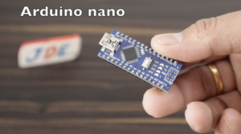

Fig.4.1 Arduino Nano

4.2. ADXL335 SENSOR

The ADXL335 sensor is a compact and low-power 3-axis analog accelerometer used to measure acceleration and detect motion in the X, Y, and Z directions. It converts physical movement or vibration into corresponding analog voltage outputs, which can be read by a microcontroller such as Arduino. Operating on a 3.3V to 5V power supply, the ADXL335 provides stable and accurate tilt and motion sensing, making it suitable for applications like crash or impact detection, robotics, gesture recognition, fall detection, and vehicle accident alert systems. Due to its reliability, small size, and easy interface with embedded systems, it is widely used in academic projects, automation, and real-time monitoring systems.
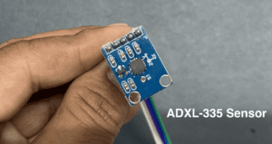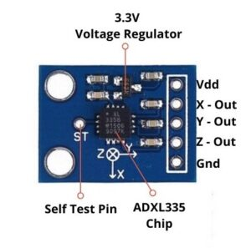

Fig.4.2 ADXL335 Sensor

4.3. SIM A7670C GSM MODULE

The SIM A7670C GSM module is a 4G LTE communication module used to enable mobile network connectivity in electronic projects and IoT systems. It allows a microcontroller, such as Arduino, to make voice calls, send SMS messages, and access the internet through mobile data. The module supports GSM, GPRS, and LTE CAT-1 networks, making it faster and more reliable than older modules like SIM800L. It is commonly used in vehicle tracking systems, accident alert systems, remote monitoring, GPS-based applications, and smart automation projects where wireless communication is required. Its compact size, low
power consumption, and strong network compatibility make it a popular choice for students and embedded system developers.

Fig.4.3 Sim A7670C GSM Module

4.4. LM2596 STEP DOWN CONVERTER

The LM2596 step-down converter is a DC-DC voltage regulator module used to convert a higher input voltage into a lower stable output voltage with high efficiency. It uses buck converter technology to deliver adjustable and smooth power to electronic circuits without generating excess heat like linear regulators. The module typically accepts an input voltage from around 4V to 40V and can output a regulated voltage between 1.25V and 35V, making it ideal for powering microcontrollers, sensors, GSM modules, and other electronics from high-voltage sources such as batteries or adapters. Because of its efficiency, reliability, and ability to supply sufficient current, it is widely used in DIY electronics, embedded projects, automation systems, and battery-powered applications.
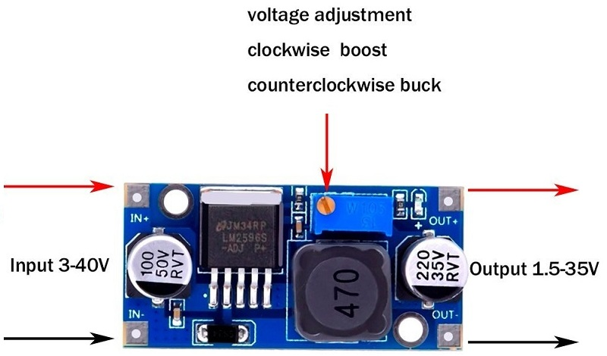

Fig.4.4 LM2596 Step Down Converter

4.5. NEO-6M MODULE

The NEO-6M module is a GPS receiver used to obtain real-time location information such as latitude, longitude, altitude, and time. It communicates with microcontrollers like Arduino through serial communication and uses satellite signals to determine the exact position anywhere on Earth. The module is compact, accurate, and supports features like built-in EEPROM for configuration storage and an external antenna for better signal reception. Because it provides precise navigation data and works with low power, the NEO-6M is widely used in vehicle tracking systems, accident alert systems, drones, mapping devices, and outdoor navigation projects.
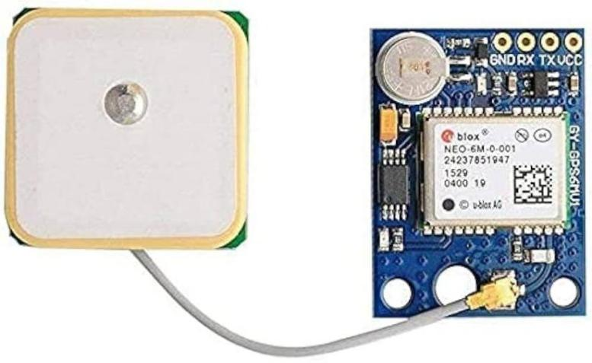
Fig.4.5 NEO-6M Module

4.6. FIRE SENSOR

A fire sensor is an electronic sensor used to detect the presence of fire or flames by sensing light emitted in the infrared wavelength. When a flame is detected, the sensor sends a signal to a microcontroller or alarm system to trigger safety actions such as activating a buzzer, sending alerts, or turning off electrical equipment. Fire sensors are widely used in fire detection systems, safety automation, industrial monitoring, and home security applications due to their fast response, low power consumption, and ability to detect flames from a distance.
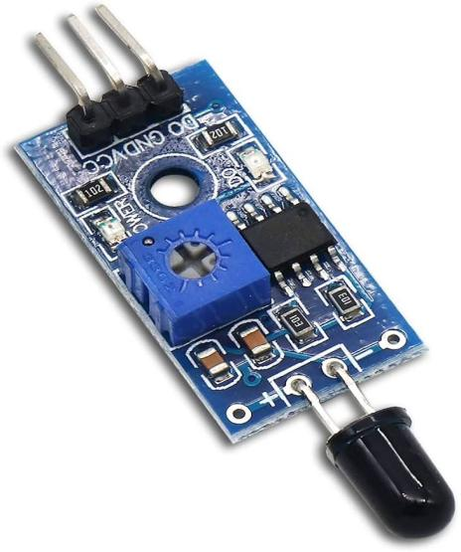

Fig.4.6 Fire Sensor

4.7. SMOKE SENSOR

A smoke sensor is an electronic device used to detect the presence of smoke particles in the air, which is often an early indication of fire. It works by sensing changes in air quality or light reflection within the sensor chamber and outputs a signal when smoke is detected. This signal can activate alarms, trigger safety mechanisms, or send alerts through microcontrollers like Arduino. Smoke sensors are commonly used in fire safety systems, home security, industrial monitoring, and automation applications due to their high sensitivity, quick response time, and reliability in detecting potential fire hazards before serious damage occurs.

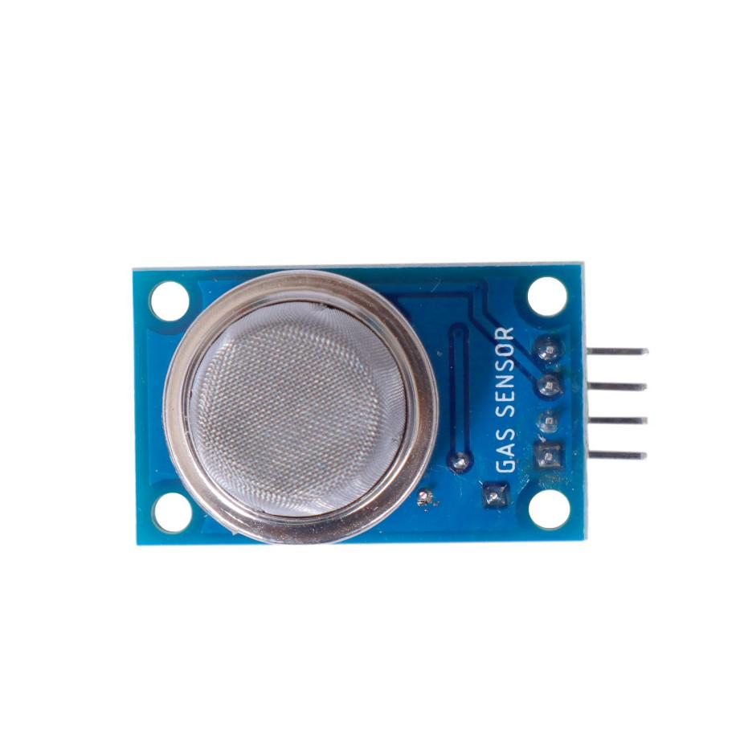
Fig.4.7 Smoke Sensor

CHAPTER 5

5.1 BLOCK DIAGRAM

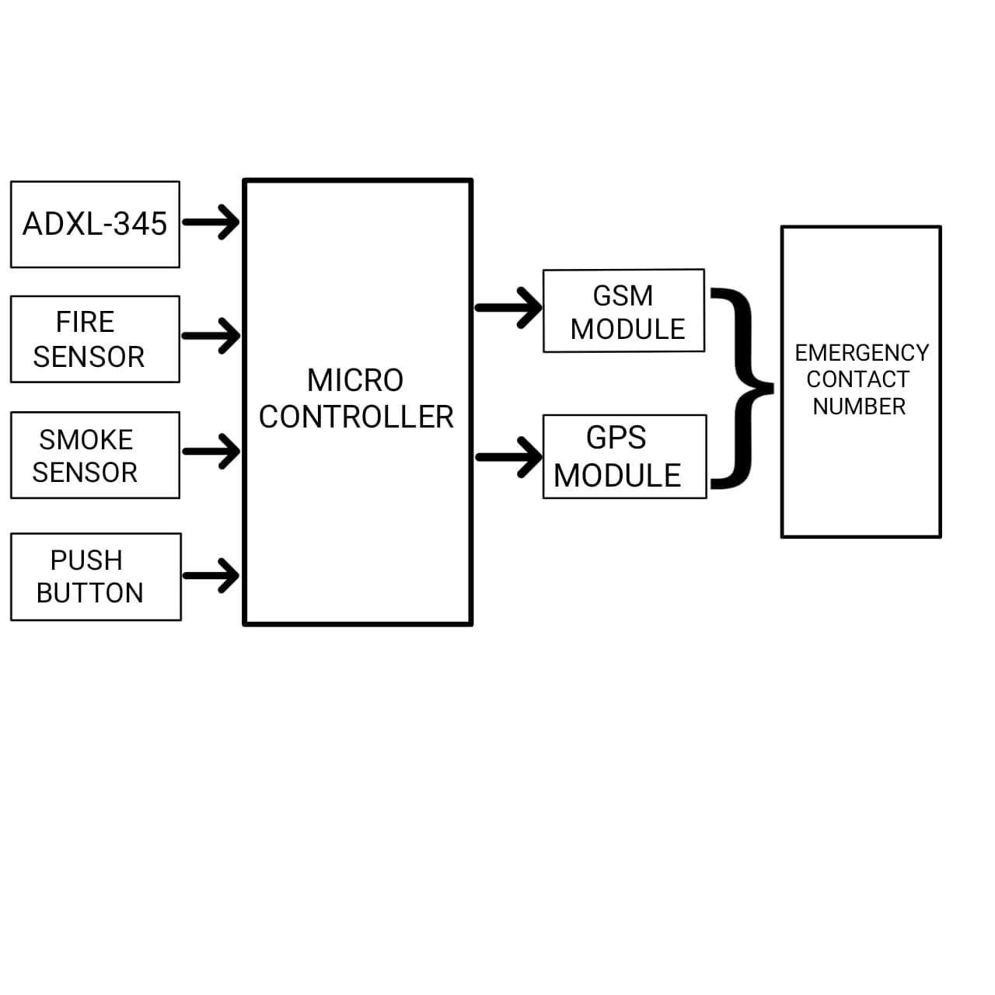
Fig.5.1 Block Diagram

5.2 CIRCUIT DIAGRAM

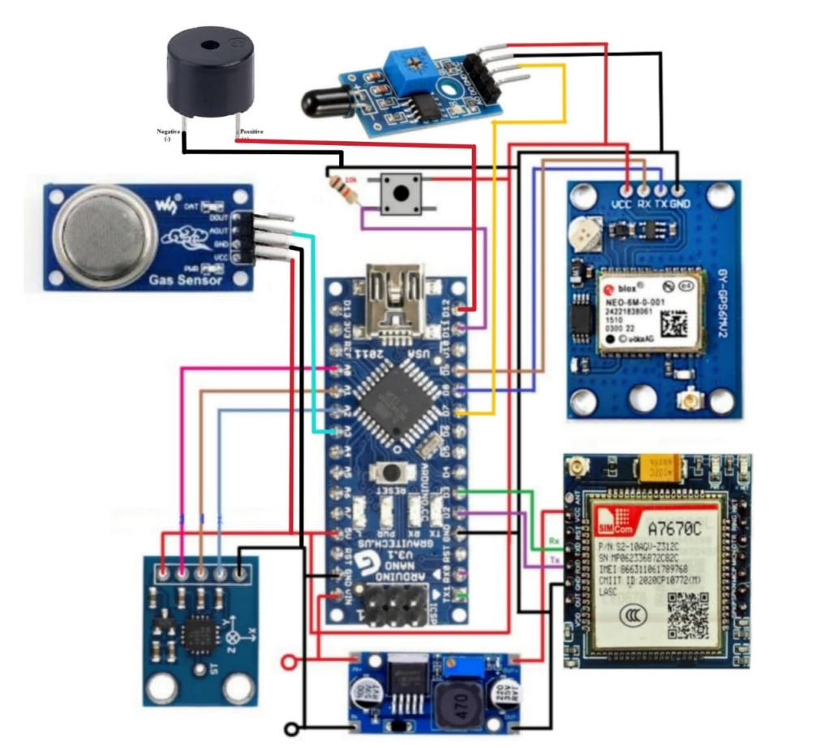
Fig.5.2 Circuit Diagram
CHAPTER 6

CODING

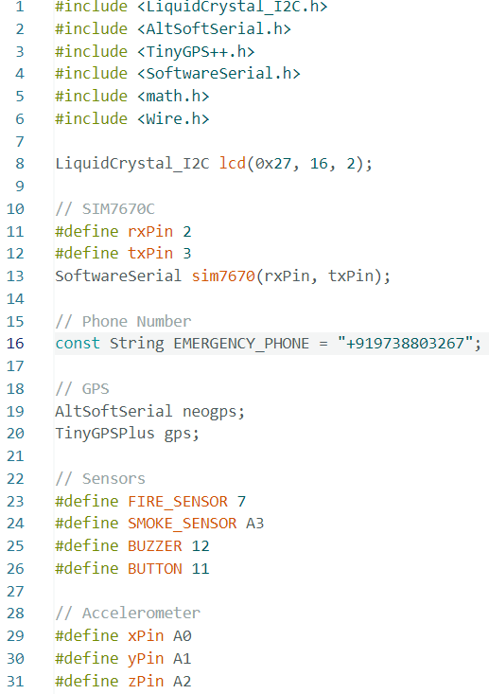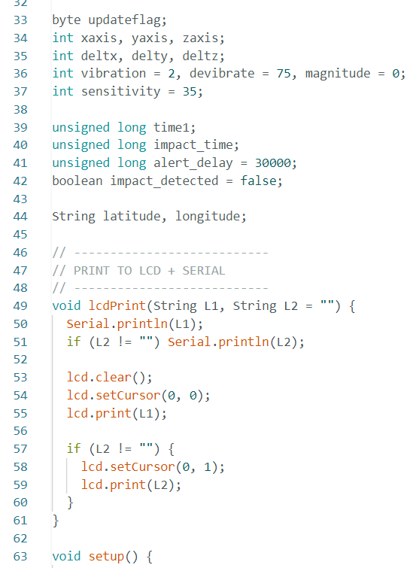

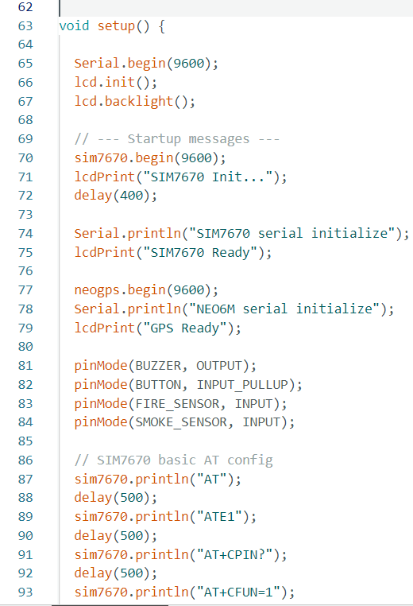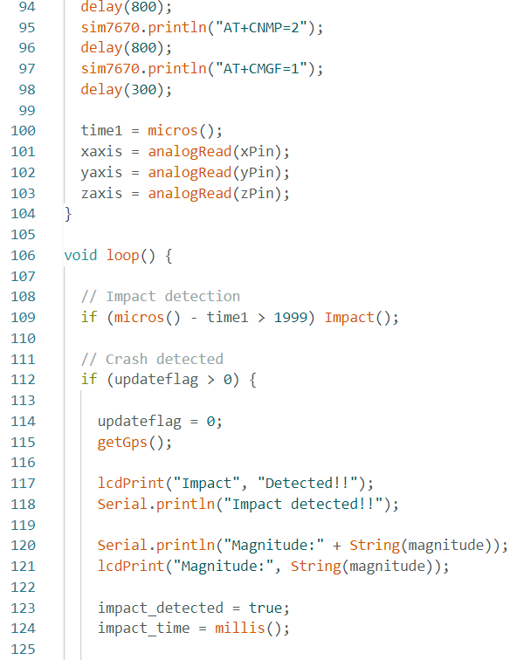
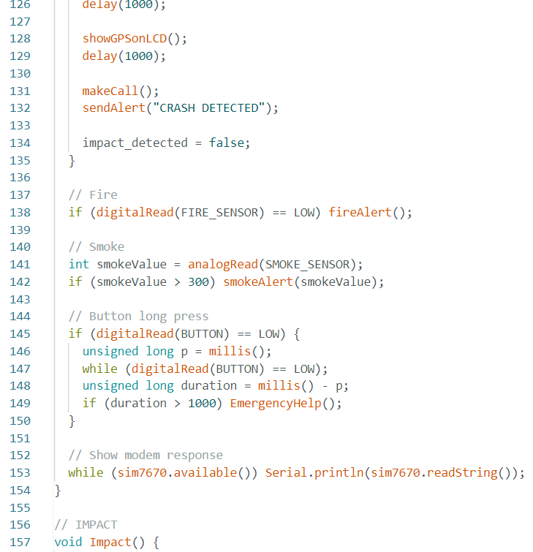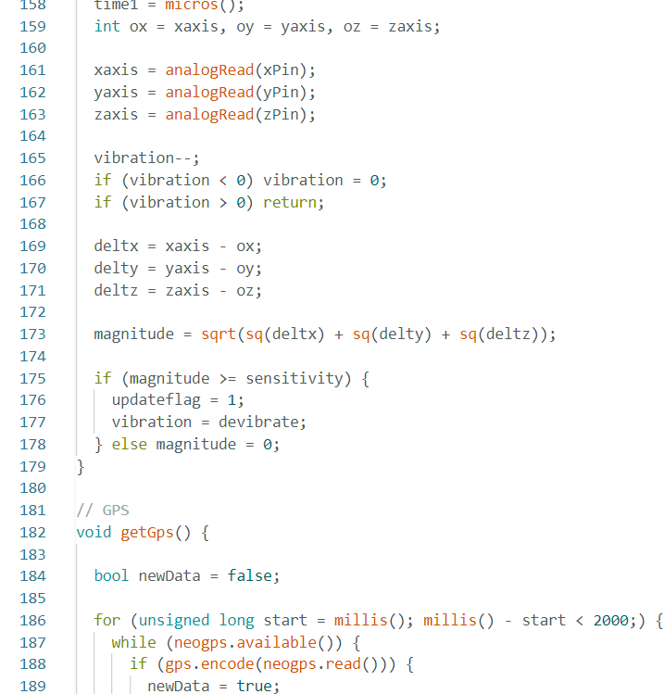
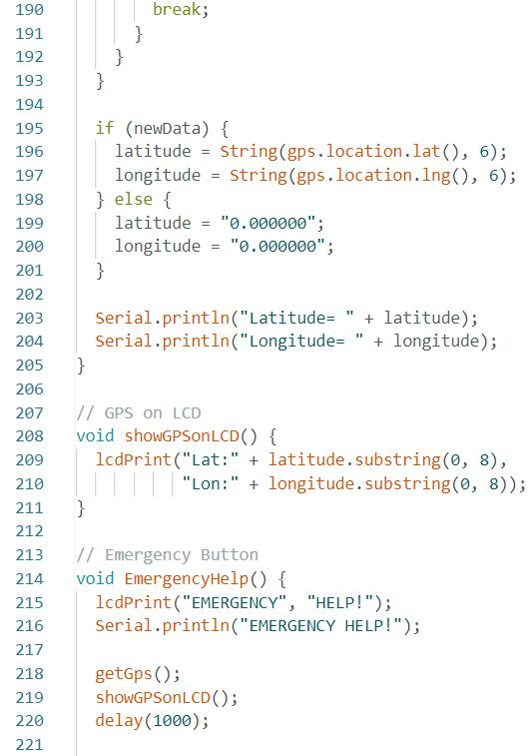
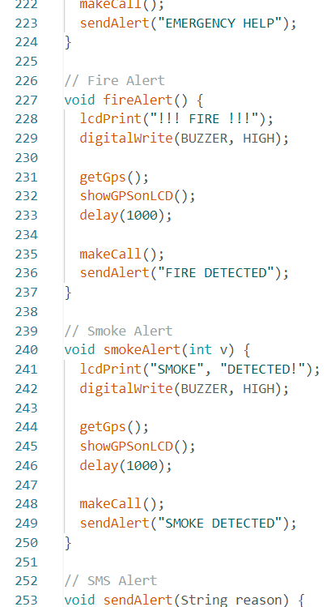

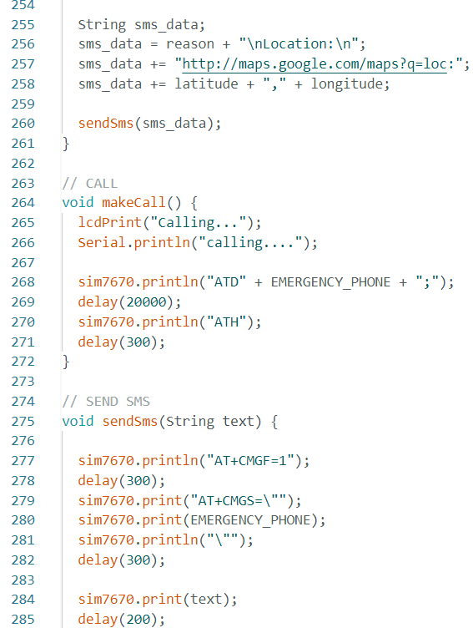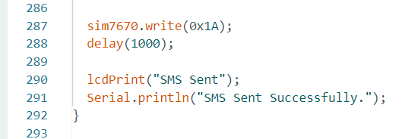

Fig.6 code

CHAPTER 7

WORKING MODULE AND SERIAL MONITORING

7.1 WORKING MODULE

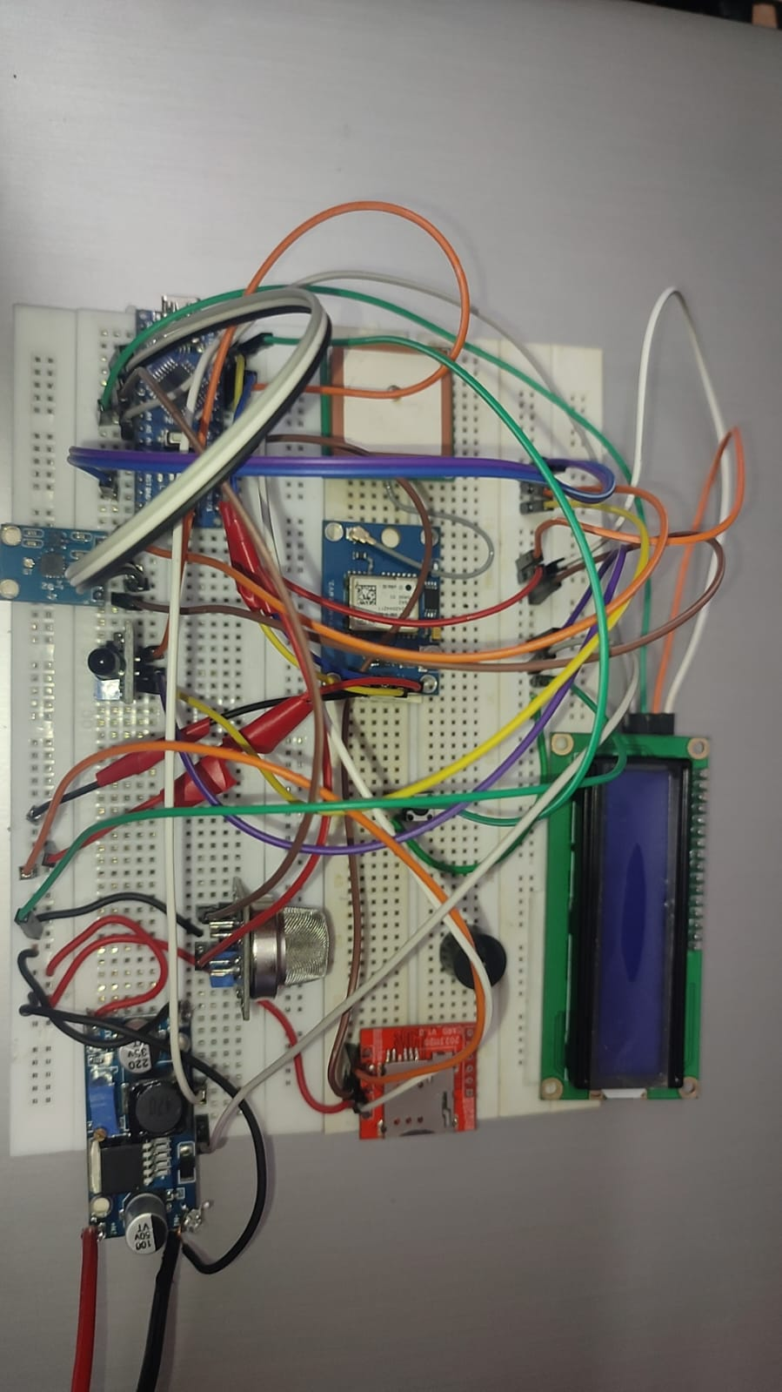

Fig.7.1 Working Module

7.2 SERIAL MONITORING OUTPUT

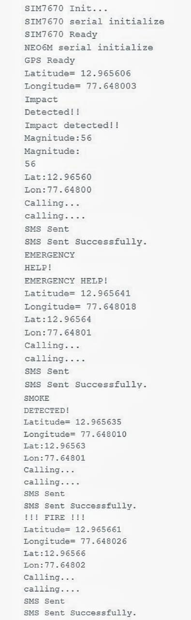

Fig.7.2 Serial Monitoring Output
CHAPTER 8

CONCLUSION AND FUTURE SCOPE

8.1 CONCLUSION

The Vehicle Accident Alert System presented in this project offers an effective solution to reduce fatalities caused by delayed emergency response during road accidents. By automatically detecting collisions using impact sensors and instantly transmitting the vehicle’s GPS location through GSM/LTE communication, the system significantly minimizes the time required for emergency services to reach the accident site. The inclusion of a manual alert button further enhances safety by allowing occupants to request help during emergency situations even without an accident.

Additionally, the integration of fire and smoke sensors provides early detection of hazardous conditions inside the vehicle, enabling rapid alert generation and timely response. The system ensures continuous monitoring and reliable communication by displaying alerts on an onboard screen and sending notifications via SMS or calls to predefined contacts or emergency services.

Overall, this project demonstrates a practical, low-cost, and reliable approach to improving road safety. The Vehicle Accident Alert System not only enhances driver and passenger security but also contributes to saving lives by ensuring faster medical assistance during critical situations. With further improvements and real-time integration, this system has strong potential for wide-scale implementation in modern vehicles.

8.2 FUTURE SCOPE

1. Vehicle-to-Vehicle (V2V) Communication
The system can be enhanced by implementing Vehicle-to-Vehicle communication, allowing nearby vehicles to exchange real-time accident and hazard information. This enables early warnings to approaching vehicles, helping drivers take preventive actions and reducing the chances of secondary accidents.

2. Vehicle-to-Infrastructure (V2I) Integration
Future development can include communication between vehicles and roadside infrastructure such as traffic signals and smart sensors. This integration allows traffic management systems to automatically detect accidents, control traffic flow, and provide priority access for emergency vehicles.

3. Advanced Communication Technologies
With the adoption of advanced communication technologies such as 5G and future 6G networks, the system can achieve faster and more reliable alert transmission. Reduced latency ensures that accident notifications and GPS location details reach emergency services with minimal delay, improving response time and saving lives.

4. Cloud-Based Emergency Response System
Integrating cloud computing enables real-time storage and sharing of accident data with emergency services, hospitals, and traffic authorities. This improves coordination, enables quicker dispatch of rescue teams, and supports long-term data analysis for improving road safety.

5. Integration with Autonomous Vehicles
As autonomous and semi-autonomous vehicles become more common, the accident alert system can play a crucial role in cooperative driving. Connected vehicles can automatically adjust speed, change lanes, or apply emergency braking based on shared accident information, improving decision-making and reducing human error.

6. Smart City and Emergency Response Integration
The system can be integrated with smart city frameworks, enabling seamless communication between vehicles, traffic management systems, and emergency services. This integration ensures faster ambulance dispatch, optimized traffic flow around accident zones, and improved urban mobility management.

CHAPTER 9

REFERENCES

Research Papers ;

Vehicle Accident Detection System Using GPS, GSM, and Accelerometer with Arduino Uno — P. Vishnu Kumar, Md Sarfaraz Nasirjah, Akula Pavan Kalyan, H Samara Simha Reddy, M Murali Das (2021)

Design & Development of Arduino Based Vehicle Accident Alert System Using Gps, Gsm Module, Distance & Force Sensor — Suhas Sanap, Vedant Patil, Harshal Buchake, Dr. Jeet Patil (2024)

Automatic Accident Detection and Rescue System — Dheeraj Yadav, Kavita Verma, Priyanka Pandey (2025)

Accident Detection And Avoidance Using Vehicle To Vehicle Communication (v2v) International Research Journal Of Engineering And Technology (IRJET) Volume 10 Issue 05 May 2023
Google Scholar

Road Accident Detection and Indication System Lavanya, Y., BhagyaSri, P., Bhuvana Sri, P., & Noha Namratha, K. ( 2023, February )
CrossRef Google Scholar

Books ;

Algorithm Concept for Crash Detection in Passenger Cars — André Leschke (2020)

Vehicles, Drivers, and Safety — John Hansen, Kazuya Takeda, Gerhard Schmidt, Huseyin Abut (2020)

The Intelligent Safety of Automobile — Jianqiang Wang, Bingbing Nie, Hong Wang (2024)

Websites ;

https://circuitdigest.com/microcontroller-projects/arduino-based-accident-alert-system-using-gps-gsm-accelerometer - “Arduino Based Vehicle Accident Alert System using GPS, GSM and Accelerometer”

https://srrobotics.in/product/accident-alert-system/ - A commercial-style product page for an "Accident Alert System" (GSM + GPS + shock/gyro sensors)

https://arduinoexpert.com/car-crash-alert-system-using-arduino/ - Car Crash Alert System Using Arduino and GSM, GPS, MPU6050, and FSR402”:

